GAME DESIGN DOCUMENT

PaliPali

Hyechan Shin 003991873

Applied Tools & Project 1 Video
Summary of the tools used to build PaliPali:

Game engine / source code: Unity 6.5 (6000.5), scripted in C#, edited in Visual Studio Code with the C# Dev Kit extension.

Graphics: base background and character-run asset pack from YouTuber Nomad Coder https://on.unitysquare.co.kr/3ZMF3O7. The playable character artwork was generated with Google Gemini and had its background removed with https://remove.bg before import into Unity.

SFX / Music: background and intro music are two tracks from DanAndPhil's copyright-free "All Beats" collection - "You Won't Believe What Happened" (background loop) and "Ready Player Two" (plays when a run starts). Five sound effects (jump, hit, eat, power-up, game over) were custom-made with https://sfxr.me/

Version control: Git, hosted on GitHub, managed with GitHub Desktop (repository: https://github.com/hyechanshin/Runner-Man-2D-Unity-Game-Project ).

PaliPali - Unity Dev Tools & Process Walkthrough: https://youtu.be/yWg6DU5MX2Y

Gameplay video: https://youtu.be/MnwQKv1vyFM

Playable build: https://play.unity.com/en/games/a0448229-50a7-46d4-8f90-7574e6229f9e/palipali

Executive Summary, Quick overview
"PaliPali" is an endless running platformer video game created using Unity, featuring an urban landscape with Korean elements. The user moves continuously through the city landscape and jumps to avoid enemies, namely a delivery driver and a fast-running grandmother (named Halmoni), and collects Korean foods such as chilies and cabbage cabbages which help in increasing health along with a golden cabbage that gives temporary invincibility. The number of hearts available initially decreases with each encounter with enemies, and once all hearts are lost, the run gets over. The time taken to survive the game, considering the selected difficulty level, forms the score for the game, with bonuses awarded for picking up foods and a high score recorded for each difficulty level.

2. Target Audience
The game PaliPali is designed for casual gamers who like arcade games that last for shorter periods of time. This includes adjustable difficulty levels (EASY / NORMAL / HARD) and two character options that allow beginners to feel comfortable with playing this game. PaliPali includes tap input functionality which makes it compatible with both desktop and touchscreen devices.

3. Main Characters
The player chooses between two playable runners on the title screen (Up/Down arrows): RUNNER, a male character with 3 hearts and a jump force of 15, and RUNNER F, a female character with 2 hearts but a higher jump force of 20 - trading survivability for more precise obstacle clearance. Neither character has combat abilities; their only actions are running (automatic) and jumping.

4. Main Features

4.1 Main mechanics
The core loop: keep running, jump to dodge enemies, and collect food to stay alive. The player has a set number of hearts (3 or 2, depending on the chosen character); colliding with an enemy costs one heart, colliding with a food item (gochu or baechu) restores one heart, and colliding with the rare golden baechu grants temporary invincibility. The run ends when hearts reach zero. Score is based on survival time scaled by the chosen difficulty's multiplier, plus one bonus point per food item collected. Difficulty (EASY / NORMAL / HARD, chosen with Left/Right arrows) sets the starting speed, maximum speed, ramp rate and score multiplier, and each difficulty tracks its own separate high score via PlayerPrefs.

4.2 Movement

The character will move along a single axis on its own, while the user's only role is to jump using the Space bar, mouse click, or tap on mobile devices, all using the same TapInput component. The action of pressing the jump button while grounded causes the character to jump with a specific jump force depending on the selected character. Obstacles, enemies, and food will approach the player continuously, and the speed will increase over time according to the difficulty level.

4.3 Physics

The player’s movement and interactions when colliding are performed using Unity’s inbuilt 2D physics engine. The player has a Rigidbody2D that jumps using the impulse force along with Unity’s gravity to make a natural jump; the isGrounded parameter, checked using OnCollisionEnter2D on the platforms, will not allow the player to jump again while in air.

4.4 Multiplayer Mode
None - PaliPali is a single-player experience only.

5. Genre, Setting, Concept Art book*
PaliPali is a 2D side-scrolling endless runner set in a stylized, Korean-flavored pixel-art cityscape. Three parallax background layers - sky, buildings, and a street-level platform - scroll at different speeds to create a sense of depth and constant forward motion
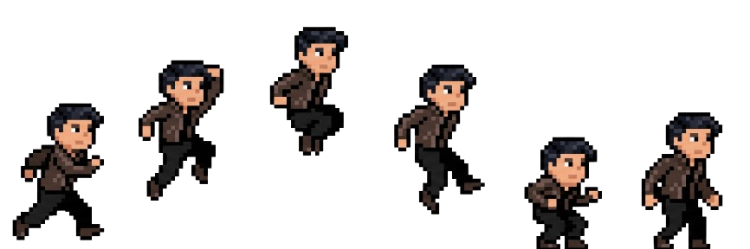

6. Enemies, NPCs, Other objects
PaliPali features two enemy types that spawn and scroll toward the player: a delivery-rider enemy and a fast-moving Halmoni (grandmother) enemy, both of which cost the player a heart on contact. Three collectible food objects counter these: gochu (chili pepper) and baechu (cabbage), which each restore one heart, and a rare golden baechu, which grants the player temporary invincibility. Buildings/obstacles, enemies and food are each driven by a shared Spawner / Mover / Destroyer script trio living on dedicated spawner objects (a building spawner, an enemy spawner, and food/gold spawners), with every prefab tagged by type so the player's trigger-collision logic can respond correctly.

7. Story board, script*

7.1 Story overview
PaliPali doesn't carry a deep narrative, in keeping with its small arcade scope: the player is simply trying to get through a hectic, obstacle-filled city as fast, and for as long as possible, in the spirit of 빨리빨리 ("hurry, hurry"), while dodging a delivery rider and a determined grandmother, and grabbing food along the way to stay standing.

7.2 Progression, World 1
Rather than discrete worlds or stages, PaliPali is a single continuous run whose challenge escalates smoothly over time: speed ramps up the longer the player survives (base + elapsed × rampRate, capped at a difficulty-specific maximum). The player sets their starting challenge level up front via the EASY / NORMAL / HARD difficulty selector on the title screen, each with its own starting speed, ramp rate, max speed and score multiplier.

8. Technical definitions, Tech guide*

8.1 Platforms, versions
Built in Unity 6.5 (6000.5) using C#, and deployed as a browser build via Unity Play - playable directly at https://play.unity.com/en/games/a0448229-50a7-46d4-8f90-7574e6229f9e/palipali in a standard browse, with no installation or developer mode required. Touch input is supported in-browser, though no dedicated Android build has been produced.

8.2 Control Scheme
Keyboard: Press Space to jump/start/restart; use Left/Right keys to select the difficulty; use Up/Down keys to select the character from the main menu. Click/Mouse and Touch actions are merged with the Space button through a single TapInput script. This means that jumping, starting, restarting, and selecting the difficulty and character are also available on touchscreen devices.

8.3 Limitations
As a course project, PaliPali is scoped to a single continuous endless-runner level rather than multiple discrete levels or worlds, and does not include a dedicated Android build even though the interface is touch-compatible in-browser. Progress is not saved beyond the high score, which persists locally per difficulty via PlayerPrefs.

9. Business Definitions

9.1 In-app Purchases
None. PaliPali is a free, non-commercial student project.

9.2 DLC Packs
None planned.

10. Outsourced/Bought Assets
Every asset used that was not made entirely from scratch, with source and license notes:
• Background and base character/animation asset pack - YouTuber Nomad Coder (https://on.unitysquare.co.kr/3ZMF3O7).
• Player character artwork - base image generated with Google Gemini (AI image generation), background removed with https://remove.bg.
• Background music - "You Won't Believe What Happened" and "Ready Player Two" by DanAndPhil, from their copyright-free "All Beats" collection (https://youtu.be/u6xy-vXIGIY, https://youtu.be/OTeHBM7h7Hw).
• Sound effects - 5 custom SFX (jump, hit, eat, power-up, game over) created with the https://sfxr.me tool.
• Unity Input System and TextMeshPro - built-in Unity packages (Unity Technologies), used for jump/tap input handling and the score UI respectively.

